PROGRAMS :

Codes and Output:

home.html:
<!DOCTYPE html>
<head>
<title>Home - Historical Explorer</title>
<link rel="stylesheet" href="home.css" />
<script src="auth.js" defer></script>
</head>
<body>

<nav class="navbar">
<div class="logo">Historical Explorer</div>
<div class="nav-links">
<a href="index.html">Home</a>
<a href="monuments.html">Monuments</a>
<a href="tours.html">Tours</a>
<a href="about.html">About Us</a>
</div>
<div class="auth-buttons">
<button id="signinBtn" class="btn signin">Sign In</button>
<button id="signupBtn" class="btn signup">Sign Up</button>
</div>
</nav>

<header class="hero">
<div class="hero-text hover-box">
<h1 id="greeting">🌞 Good Morning, Explorer!</h1>
<p>Discover the world’s most iconic monuments and travel through history!</p>
<a href="monuments.html" class="explore-btn">Start Exploring</a>
</div>
</header>

<section class="intro">
<h2>Embark on a Journey Through Time</h2>
<p>
Explore the stories of civilizations that shaped humanity — from ancient Egypt to modern wonders.
Let curiosity be your guide!
</p>
</section>

<footer>
&copy; 2025 Historical Explorer | Designed by Aaron De Souza
</footer>

<div id="authModal" class="modal">
<div class="modal-content">
<span class="close" id="closeModal">&times;</span>
<h2 id="modalTitle">Sign In</h2>

<form id="authForm" novalidate>
<div class="form-group" id="nameGroup" style="display:none;">
<label>Full Name:</label>
<input type="text" id="fullname" name="name" placeholder="Enter full name" />
</div>

<div class="form-group">
<label>Email:</label>
<input type="email" id="email" name="email" placeholder="Enter your email" required />
</div>

<div class="form-group">
<label>Password:</label>
<input type="password" id="password" name="password" placeholder="Enter password" required />
<small id="attemptInfo"></small>
</div>

<button type="submit" id="submitBtn">Submit</button>

<p class="switch">
<span id="switchText">Don’t have an account?</span>
<a href="#" id="switchLink">Sign Up</a>
</p>
</form>
</div>
</div>

</body>
</html>

home.css:

body {
margin: 0;
font-family: 'Poppins', sans-serif;
background-color: #fff8f0;
color: #333;
}

/* Navbar */
.navbar {
display: flex;
justify-content: space-between;
align-items: center;
background-color: coral;
padding: 14px 25px;
box-shadow: 0 4px 10px rgba(0,0,0,0.1);
}

.logo {
font-size: 22px;
font-weight: bold;
color: white;
}

.nav-links a {
text-decoration: none;
color: white;
margin: 0 10px;
font-weight: bold;
transition: color 0.3s ease;
}

.nav-links a:hover {
color: #ffe0b2;
}

.auth-buttons .btn {
border: none;
border-radius: 6px;
padding: 8px 16px;
margin-left: 8px;
cursor: pointer;
font-weight: bold;
transition: all 0.3s ease;
}

.signin {
background-color: white;
color: coral;
}

.signup {
background-color: darkorange;
color: white;
}

.signin:hover, .signup:hover {
transform: scale(1.05);
}

/* Hero Section */
.hero {
background: url("history.jpg") center center / cover no-repeat;
height: 60vh;
display: flex;
justify-content: center;
align-items: center;
text-align: center;
}

.hero-text {
background: rgba(0, 0, 0, 0.5);
padding: 40px;
border-radius: 12px;
color: white;
max-width: 700px;
transition: transform 0.3s ease, background-color 0.3s ease;
}

/* Hover effect */
.hover-box {
display: flex;
flex-direction: column;
align-items: center;
justify-content: center;
}

.hover-box:hover {
transform: scale(1.05);
background-color: rgba(0, 0, 0, 0.6);
cursor: pointer;
}

/* Title hover */
.hover-box h1 {
transition: color 0.3s ease;
}

.hover-box:hover h1 {
color: gold;
}

.hero-text h1 {
font-size: 42px;
text-transform: uppercase;
margin-bottom: 10px;
letter-spacing: 2px;
}

.hero-text p {
font-size: 18px;
line-height: 1.6;
}

.explore-btn {
display: inline-block;
margin-top: 20px;
text-decoration: none;
background-color: coral;
color: white;
padding: 12px 28px;
border-radius: 8px;
font-weight: bold;
transition: 0.3s;
}

.explore-btn:hover {
background-color: darkorange;
transform: scale(1.05);
}

/* Intro Section */
.intro {
max-width: 800px;
margin: 50px auto;
background-color: #ffe5b4;
padding: 30px;
border-radius: 12px;
text-align: center;
box-shadow: 0 5px 15px rgba(0,0,0,0.1);
}

.intro h2 {
color: indianred;
margin-bottom: 10px;
}

/* Footer */
footer {
background-color: coral;
color: white;
text-align: center;
padding: 15px;
margin-top: 40px;
}

/* Modal Styling */
.modal {
display: none;
position: fixed;
inset: 0;
background: rgba(0,0,0,0.6);
justify-content: center;
align-items: center;
}

.modal-content {
background: white;
padding: 25px;
border-radius: 10px;
width: 320px;
animation: slideIn 0.4s ease;
text-align: center;
}

@keyframes slideIn {
from { transform: translateY(-50px); opacity: 0; }
to { transform: translateY(0); opacity: 1; }
}

.close {
float: right;
font-size: 20px;
color: red;
cursor: pointer;
}

.form-group {
text-align: left;
margin: 15px 0;
}

.form-group input {
width: 100%;
padding: 8px;
border-radius: 5px;
border: 1px solid #ccc;
}

button[type="submit"] {
width: 100%;
background-color: coral;
color: white;
padding: 10px;
border: none;
border-radius: 5px;
font-weight: bold;
cursor: pointer;
transition: 0.3s;
}

button[type="submit"]:hover {
background-color: darkorange;
}

.switch {
font-size: 14px;
text-align: center;
margin-top: 10px;
}
.switch a {
color: coral;
text-decoration: none;
font-weight: bold;
}
.switch a:hover {
text-decoration: underline; }

auth.js:
document.addEventListener("DOMContentLoaded", () => {
// --- 1. Element Selection ---
const signinBtn = document.getElementById("signinBtn");
const signupBtn = document.getElementById("signupBtn");
const modal = document.getElementById("authModal");
const closeModal = document.getElementById("closeModal");
const title = document.getElementById("modalTitle");
const nameGroup = document.getElementById("nameGroup");
const form = document.getElementById("authForm");
const password = document.getElementById("password");
const email = document.getElementById("email");
// This line correctly references the 'fullname' ID (now fixed in HTML)
const nameField = document.getElementById("fullname");
const attemptInfo = document.getElementById("attemptInfo");
const greeting = document.getElementById("greeting");
const switchLink = document.getElementById("switchLink");
const switchText = document.getElementById("switchText");

// --- 2. State Variables and Local Storage Setup ---
let isSignIn = true;
let attempts = 3;

// Retrieve users or initialize an empty array
let users = JSON.parse(localStorage.getItem("users")) || [];

// Pre-seed a test user if one doesn't exist
const preSeedUser = { name: "Test Admin", email: "test@example.com", password: "admin" };

if (!users.some(u => u.email === preSeedUser.email)) {
users.push(preSeedUser);
localStorage.setItem("users", JSON.stringify(users));
}

// --- 3. Initial Setup: Time-based greeting ---
const hour = new Date().getHours();
if (hour < 12) greeting.textContent = "🌞 Good Morning, Explorer!";
else if (hour < 18) greeting.textContent = "🏛️ Good Afternoon, Explorer!";
else greeting.textContent = "🌙 Good Evening, Explorer!";

// --- 4. Modal Open/Close Logic ---
signinBtn.onclick = () => openModal(true);
signupBtn.onclick = () => openModal(false);
closeModal.onclick = () => (modal.style.display = "none");
window.onclick = (e) => {
if (e.target === modal) modal.style.display = "none";
};

function openModal(signin) {
isSignIn = signin;
modal.style.display = "flex";
title.textContent = signin ? "🔑 Sign In" : "📝 Sign Up";
nameGroup.style.display = signin ? "none" : "block";
switchText.textContent = signin ? "Don’t have an account? 🤔" : "Already have an account? 🙂";
switchLink.textContent = signin ? "Sign Up" : "Sign In";
attemptInfo.textContent = "";
password.value = "";
email.value = "";
if (!signin) nameField.value = "";
password.disabled = false;
}

switchLink.onclick = (e) => {
e.preventDefault();
openModal(!isSignIn);
};

// --- 5. Validation Helpers ---
function validateEmail(email) {
return /^[^\s@]+@[^\s@]+\.[^\s@]+$/.test(email);
}

function validatePassword(pass) {
// At least 6 chars, 1 letter, 1 number
return /^(?=.*[A-Za-z])(?=.*\d)[A-Za-z\d]{6,}$/.test(pass);
}

// --- 6. Form Submission Handling ---
form.addEventListener("submit", (e) => {
e.preventDefault();
const emailVal = email.value.trim();
const passVal = password.value.trim();

if (!validateEmail(emailVal)) {
attemptInfo.textContent = "⚠️ Please enter a valid email address.";
return;
}

if (isSignIn) {
// SIGN IN LOGIC
const user = users.find((u) => u.email === emailVal);

if (!user) {
attemptInfo.textContent = "❌ No account found with that email.";
return;
}

if (passVal === user.password) {
if (confirm(`You are signing in with:\n📧 Email: ${emailVal}\n\nContinue?`)) {
// LOGIN SUCCESS HANDLER
alert('Logic Successful');
alert(`✅ Welcome back, ${user.name || "Explorer"}! 🏛️`);
modal.style.display = "none";
attempts = 3;
}
} else {
// FAILED ATTEMPT LOGIC
attempts--;
attemptInfo.textContent =
attempts > 0
? `❌ Incorrect password. ${attempts} attempt(s) left. ⚠️`
: "🚫 Too many failed attempts. Try again later.";
if (attempts <= 0) password.disabled = true;
}
} else {
// SIGN UP LOGIC
const nameVal = nameField.value.trim();

if (nameVal.length < 2) {
attemptInfo.textContent = "⚠️ Name must be at least 2 characters.";
return;
}

// Password check for 'admin' or complex validation
if (passVal.toLowerCase() !== "admin" && !validatePassword(passVal)) {
attemptInfo.textContent = "🔐 Password must be 'admin' or at least 6 characters with 1 letter and 1 number.";
return;
}

if (users.some((u) => u.email === emailVal)) {
attemptInfo.textContent = "⚠️ Account already exists. Please sign in.";
return;
}

if (confirm(`You are signing up with:\n👤 Name: ${nameVal}\n📧 Email: ${emailVal}\n🔑 Password: ${passVal}\n\nProceed?`)) {
// Save new user
users.push({ name: nameVal, email: emailVal, password: passVal });
localStorage.setItem("users", JSON.stringify(users));

// SIGN UP SUCCESS HANDLER
alert('Logic Successful');
alert("🎉 Sign-up successful! You can now sign in. ✅");
openModal(true); // Switch to Sign In view
}
}
});

// --- 7. Hover Text Animation ---
const heroText = document.querySelector(".hover-box h1");
heroText.addEventListener("mouseenter", () => {
heroText.textContent = "🏛️ Explore the Monuments!";
});
heroText.addEventListener("mouseleave", () => {
const hour = new Date().getHours();
if (hour < 12) heroText.textContent = "🌞 Good Morning, Explorer!";
else if (hour < 18) heroText.textContent = "🏛️ Good Afternoon, Explorer!";
else heroText.textContent = "🌙 Good Evening, Explorer!";
});
});

Output: Sign Up
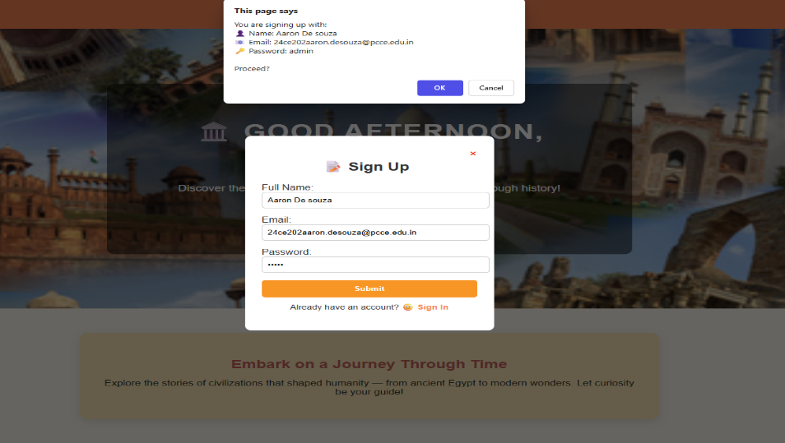

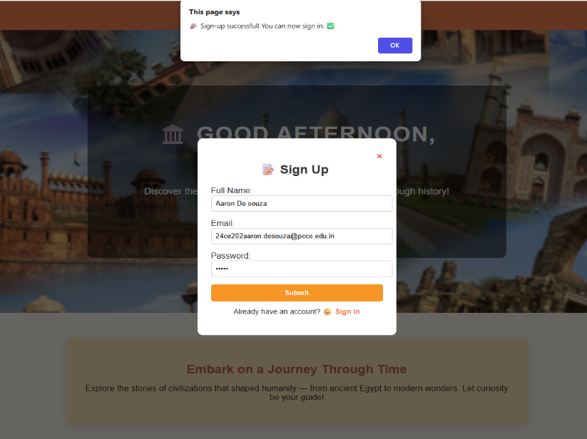

: 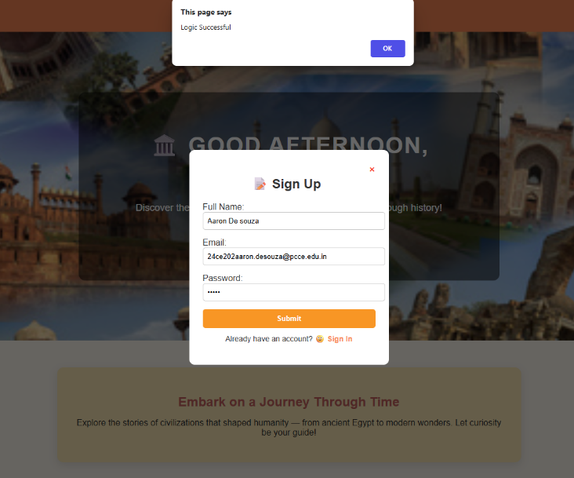

Output: Sign in

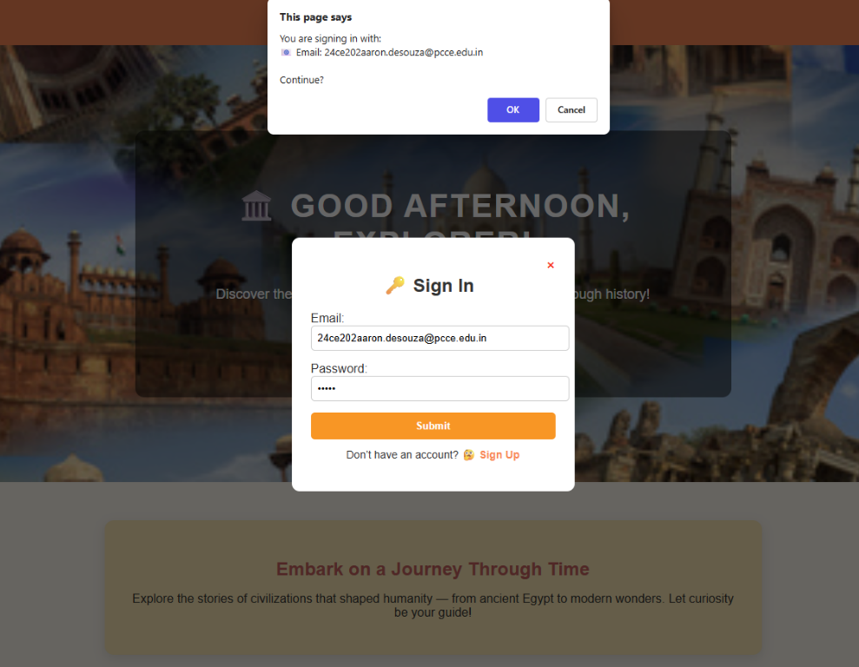

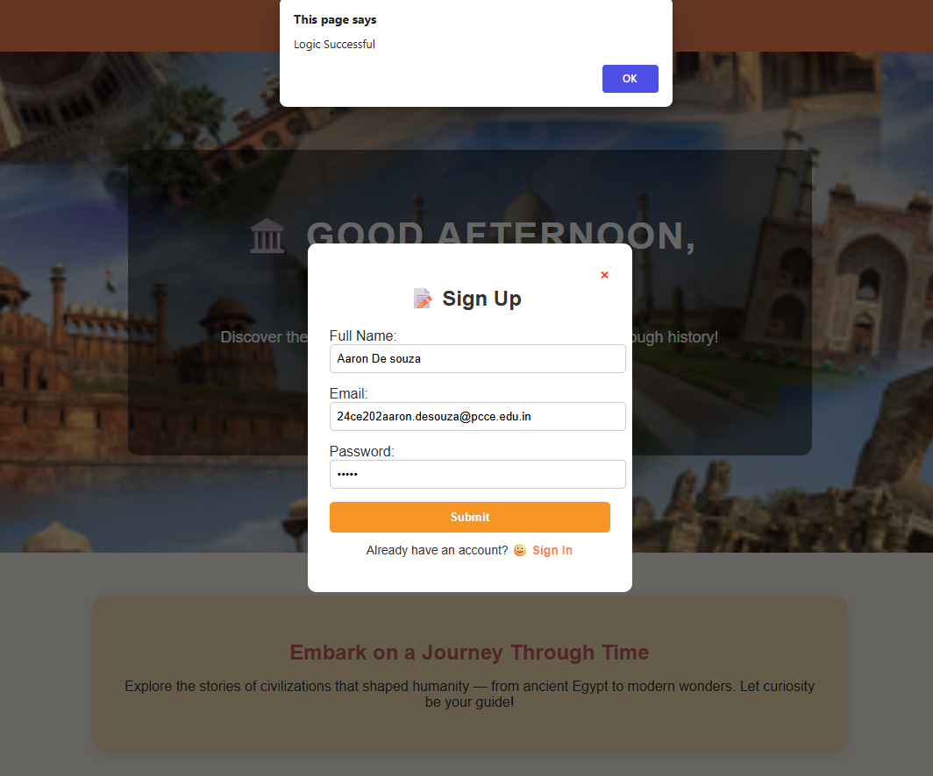

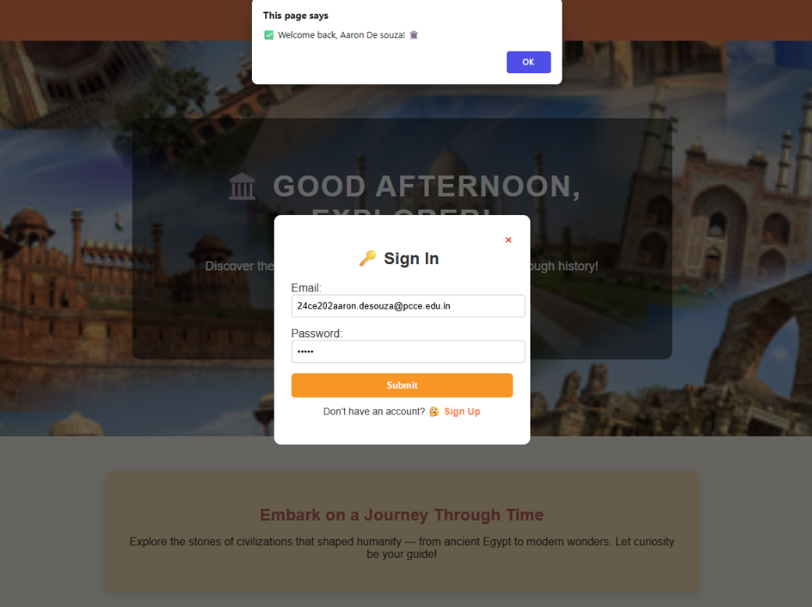

Output: Sign in Error

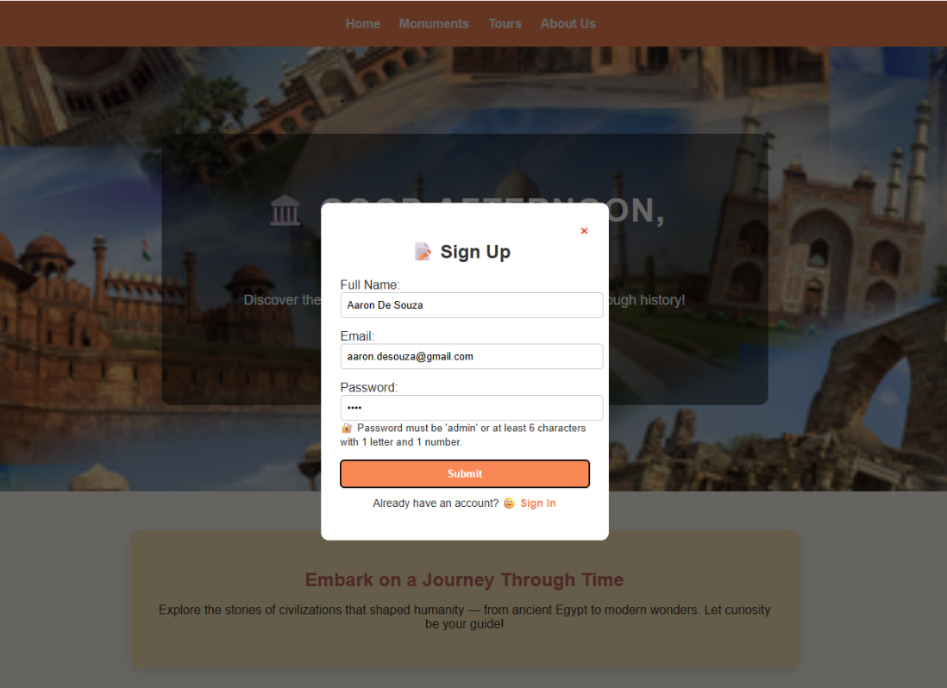

monuments.html:

<!DOCTYPE html>
<head>
<title>Monuments - Historical Places</title>
<link rel="stylesheet" href="monuments.css">
</head>
<body>

<!-- Navbar -->
<div class="navbar">
<a href="home.html">Home</a>
<a href="monuments.html">Monuments</a>
<a href="tours.html">Tours</a>
<a href="about.html">About Us</a>
<a href="register.html">Register</a>
</div>

<!-- Header -->
<header>
<h1>Famous Monuments of the World</h1>
<p>Discover the most iconic landmarks that celebrate the heritage of humanity.</p>
</header>

<!-- Main Content -->
<main class="places-container">
<div class="place-card">
<img src="https://a.cdn-hotels.com/gdcs/production110/d737/79d01da7-3020-4b44-9f2d-045801e4ba55.jpg" alt="Colosseum, Rome">
<h2>Colosseum</h2>
<p>Located in Rome, Italy — a grand amphitheater that hosted ancient gladiator battles and remains a symbol of Roman engineering.</p>
</div>
<div class="place-card">
<img src="https://www.wanderlustmagazine.com/wp-content/uploads/2023/11/great-wall-of-china.jpg" alt="Great Wall of China">
<h2>Great Wall of China</h2>
<p>A breathtaking fortification stretching over 13,000 miles across northern China, built to protect ancient Chinese states.</p>
</div>
<div class="place-card">
<img src="https://media.architecturaldigest.com/photos/59fc9a17f0511d186d92102f/master/pass/Great%20Pyramid%20of%20Giza%201.jpg" alt="Pyramids of Giza">
<h2>Pyramids of Giza</h2>
<p>One of the Seven Wonders of the Ancient World, located near Cairo, Egypt — a marvel of human craftsmanship and mystery.</p>
</div>
<div class="place-card">
<img src="https://media.sciencephoto.com/image/f0388482/800wm/F0388482-Aerial_view_of_the_Eiffel_Tower,_Paris,_France.jpg"
alt="Eiffel Tower, France">
<h2>Eiffel Tower, France</h2>
<p>
An iconic iron lattice tower located in Paris, France — one of the most recognized landmarks in the world, symbolizing art, architecture, and romance.
</p>
</div>
<div class="place-card">
<img src="https://images.fineartamerica.com/images/artworkimages/mediumlarge/3/christ-the-redeemer-delphimages-photo-creations.jpg"
alt="Christ the Redeemer, Brazil" style="object-fit: cover; object-position: center 20%; height: 230px;">
<h2>Christ the Redeemer, Brazil</h2>
<p>
Iconic Art Deco statue of Jesus atop Mount Corcovado in Rio de Janeiro, symbolizing faith and hope embraced by millions.
</p>
</div>
<div class="place-card">
<img src="https://thumbs.dreamstime.com/b/statue-liberty-stand-19791613.jpg" alt="Statue of Liberty" class="statue-img">
<h2>Statue of Liberty</h2>
<p>Gifted by France to the United States, this colossal statue in New York Harbor symbolizes freedom and democracy.</p>
</div>
<div class="place-card">
<img src="https://smarthistory.org/wp-content/uploads/2023/11/799603181_d199a81331_o.jpg" alt="Angkor Wat, Cambodia">
<h2>Angkor Wat</h2>
<p>The world’s largest religious monument located in Cambodia, known for its majestic Khmer architecture and sunrise views.</p>
</div>
<div class="place-card">
<img src="https://img.freepik.com/premium-photo/fuji-mountain-lake-morning-with-autumn-seasons-leaves-japan_763111-13413.jpg" alt="Mount Fuji, Japan">
<h2>Mount Fuji</h2>
<p>Japan’s tallest peak — a sacred volcanic mountain renowned for its near-perfect symmetry and tranquil surroundings.</p>
</div>
<div class="place-card">
<img src="https://tse1.mm.bing.net/th/id/OIP.ymWt0I3oeUE6weW-kYO7LQHaFk?rs=1&pid=ImgDetMain&o=7&rm=3" alt="Taj Mahal, India">
<h2>Taj Mahal</h2>
<p>Located in Agra, India, the Taj Mahal is a magnificent white marble mausoleum built by Mughal Emperor Shah Jahan in memory of his beloved wife Mumtaz Mahal.</p>
</div>
<div class="place-card">
<img src="https://img.freepik.com/premium-photo/chichen-itza-mayan-legacy-stone_984027-264581.jpg" alt="Chichén Itzá, Mexico">
<h2>Chichén Itzá</h2>
<p>
Located in the Yucatán Peninsula of Mexico, Chichén Itzá was a powerful Mayan city famed for its pyramid of Kukulkan — a masterpiece of astronomy and architecture.
</p>
</div>
<div class="place-card">
<img src="https://luxurywebmagazine.com/wp-content/uploads/2024/04/LW-RN7.jpg"
alt="Rapa Nui, Easter Island">
<h2>Rapa Nui, Easter Island</h2>
<p>
Famous for its mysterious <b>Moai statues</b>, carved by the Rapa Nui people on Easter Island, a remote Polynesian cultural treasure.
</p>
</div>
<div class="place-card">
<img src="https://curiosmos.com/wp-content/uploads/2019/11/A-view-of-the-ancient-Inca-city-of-Macchu-Picchu-768x511.jpg" alt="Machu Picchu, Peru">
<h2>Machu Picchu</h2>
<p>An ancient Incan citadel nestled high in the Andes Mountains of Peru, offering breathtaking views and historical mystery.</p>
</div>
</main>

<!-- Footer -->
<footer>
&copy; 2025 Historical Explorer | Designed by Aaron De Souza
</footer>
</body>
</html>

monuments.css:

/* General Styles */
body {
margin: 0;
font-family: 'Poppins', sans-serif;
background-color: #f4f7fb;
color: #333;
}

/* Navbar */
.navbar {
display: flex;
justify-content: center;
background-color: coral;
padding: 12px;
gap: 10px;
}

.navbar a {
text-decoration: none;
color: white;
font-weight: bold;
background-color: darkorange;
padding: 10px 15px;
border-radius: 5px;
transition: all 0.3s ease;
}

.navbar a:hover {
background-color: #ff7043;
transform: scale(1.05);
}

/* Header */
header {
text-align: center;
padding: 40px 20px;
background-color: #fff3e0;
border-bottom: 4px solid coral;
}

header h1 {
font-size: 36px;
color: indianred;
margin-bottom: 10px;
text-transform: uppercase;
}

header p {
font-size: 18px;
color: #444;
}

/* Monuments / Places Section */
.places-container {
display: flex;
flex-wrap: wrap;
justify-content: center;
gap: 25px;
padding: 30px;
max-width: 1200px;
margin: auto;
}

.place-card {
background-color: white;
border-radius: 12px;
box-shadow: 0 5px 15px rgba(0,0,0,0.1);
width: 300px;
text-align: center;
overflow: hidden;
transition: transform 0.3s ease, box-shadow 0.3s ease;
}

.place-card:hover {
transform: translateY(-5px);
box-shadow: 0 10px 20px rgba(0,0,0,0.2);
}

.place-card img {
width: 100%;
height: 220px;
object-fit: cover;
transition: transform 0.3s ease;
}

.place-card img:hover {
transform: scale(1.05);
}

.place-card h2 {
color: darkorange;
margin: 10px 0;
font-size: 22px;
}

.place-card p {
padding: 0 15px 15px;
font-size: 16px;
line-height: 1.5;
color: #555;
}

/* Footer */
footer {
text-align: center;
background-color: coral;
color: white;
padding: 15px;
margin-top: 50px;
}

footer a {
color: #fff;
text-decoration: underline;
}

output:

tours.html:

<!DOCTYPE html>
<head>
<title>Tours - Historical Places</titVle>
<link rel="stylesheet" href="tours.css">
</head>
<body>

<!-- Navbar -->
<div class="navbar">
<a href="home.html">Home</a>
<a href="monuments.html">Monuments</a>
<a href="tours.html">Tours</a>
<a href="about.html">About Us</a>
<a href="register.html">Register</a>
</div>

<!-- Header -->
<header>
<h1>Explore Historical Tours</h1>
<p>Travel through time as you explore breathtaking historical destinations around the world.</p>
</header>

<!-- Tours Section -->
<main class="places-container">
<!-- Jaipur, India -->
<div class="place-card">
<img src="https://cdn.pixabay.com/photo/2019/03/01/11/35/jaipur-4027735_640.jpg?w=900" alt="Jaipur, India">
<h2>Jaipur, India</h2>
<p>Jaipur, the Pink City, is famous for its vibrant architecture, palaces, and forts. Highlights include Hawa Mahal, City Palace, and Amber Fort, showcasing royal Rajput heritage.</p>
</div>
<!-- Temple of Heaven Beijing, china -->
<div class="place-card">
<img src="temple of heaven.jpg" alt="Xi’an, China">
<h2>Temple of Heaven Beijing, China</h2>
<p>
The Temple of Heaven in Beijing was built for emperors to pray for good harvests and symbolizes the connection between Heaven and Earth.
</p>
</div>
<!-- Cusco, Peru -->
<div class="place-card">
<img src="https://www.truemountaintraveler.com/wp-content/uploads/2019/06/main-square-cusco-peru.jpg" alt="Cusco, Peru">
<h2>Cusco, Peru</h2>
<p>Cusco, the ancient capital of the Incan Empire, features colonial architecture built atop Incan ruins. Explore the historic main square and nearby archaeological sites.</p>
</div>
<!-- Phnom Penh, Cambodia -->
<div class="place-card">
<img src="https://media.istockphoto.com/id/470641878/photo/phnom-penh-royal-palace-complex.jpg?s=612x612&w=0&k=20&c=-Fl94Da-CxnD2Ax6uGKMO-RDaWGFBfqGbVlyZJUUsVc=" alt="Phnom Penh, Cambodia">
<h2>Phnom Penh, Cambodia</h2>
<p>Phnom Penh, the capital of Cambodia, is home to the Royal Palace and Silver Pagoda. Visitors can experience the grandeur of Khmer architecture and Cambodia’s rich royal history.</p>
</div>
<!-- Mount Rushmore, USA -->
<div class="place-card">
<img src="https://fullsuitcase.com/wp-content/uploads/2019/06/Mt-Rushmore-as-seen-from-the-Grand-View-Terrace.jpg" alt="Mount Rushmore, USA">
<h2>Mount Rushmore, USA</h2>
<p>Mount Rushmore features the colossal faces of four U.S. presidents carved into granite. It represents American history, leadership, and artistic achievement.</p>
</div>
<!-- Rome, Italy -->
<div class="place-card">
<img src="https://media.timeout.com/images/105211701/750/562/image.jpg" alt="Rome, Italy">
<h2>Rome, Italy</h2>
<p>Rome, the Eternal City, offers iconic landmarks like the Colosseum, Roman Forum, and Pantheon. Discover centuries of art, culture, and Roman history at every corner.</p>
</div>
<!-- Petra, Jordan -->
<div class="place-card">
<img src="https://twoandfro.com/wp-content/uploads/2020/02/2020.01.29-Jordan-Petra-0024.jpg" alt="Petra, Jordan">
<h2>Petra, Jordan</h2>
<p>The ancient city of Petra, carved into rose-red cliffs, is a UNESCO World Heritage site. Explore its intricate facades, tombs, and the iconic Treasury (Al-Khazneh).</p>
</div>
<!-- Fushimi Inari Shrine Kyoto, Japan -->
<div class="place-card">
<img src="fushimi inari taisha japan.jpg" alt="Kyoto, Japan">
<h2>Fushimi Inari Shrine Kyoto, Japan</h2>
<p>Fushimi Inari Shrine in Kyoto, Japan, is famous for its thousands of red torii gates and is dedicated to Inari, the Shinto god of rice and prosperity.
</p> </div> </main>

<!-- Footer -->
<footer>
&copy; 2025 Historical Explorer | Designed by Aaron De Souza
</footer>
</body>
</html>

tours.css:

body {
background-color: PeachPuff;
font-family: 'Poppins', Arial, sans-serif;
margin: 0;
padding: 0;
color: #333;
text-align: center;
}

/* Navbar */
.navbar {
display: flex;
justify-content: center;
background-color: Coral;
padding: 12px;
gap: 10px;
}

.navbar a {
text-decoration: none;
color: white;
font-weight: bold;
background-color: DarkOrange;
padding: 10px 15px;
border-radius: 5px;
transition: all 0.3s ease;
}

.navbar a:hover {
background-color: #ff7043;
transform: scale(1.05);
}

/* Header */
header {
text-align: center;
padding: 40px 20px;
background-color: #fff3e0;
border-bottom: 4px solid coral;
}

header h1 {
font-size: 36px;
color: indianred;
margin-bottom: 10px;
text-transform: uppercase;
}

header p {
font-size: 18px;
color: #444;
}

/* Tours / Monuments Cards */
.places-container {
display: flex;
flex-wrap: wrap;
justify-content: center;
gap: 30px;
padding: 20px;
}

.place-card {
background-color: #fff;
border-radius: 12px;
box-shadow: 0 4px 10px rgba(0,0,0,0.1);
width: 300px;
overflow: hidden;
transition: transform 0.3s ease, box-shadow 0.3s ease;
text-align: center;
padding-bottom: 15px;
}

.place-card:hover {
transform: scale(1.05);
box-shadow: 0 8px 18px rgba(0,0,0,0.2);
}

.place-card img {
width: 100%;
height: 200px;
object-fit: cover;
border-bottom: 3px solid #ffb74d;
}

.place-card h2 {
margin: 15px 10px 5px;
color: #d35400;
font-size: 20px;
font-weight: 600;
}

.place-card p {
font-size: 14px;
color: #333;
margin: 0 10px;
line-height: 1.4;
}

/* Footer */
footer {
background-color: #f2f2f2;
padding: 15px;
text-align: center;
font-size: 14px;
margin-top: 30px;
color: #555;
}

output:

about.html:

<!DOCTYPE html>
<head>
<title>About Us - Historical Places</title>
<link rel="stylesheet" href="about.css" />
<style>
body {
margin: 0;
font-family: 'Poppins', sans-serif;
background-color: PeachPuff;
color: #333;
}

/* Navbar */
.navbar {
display: flex;
justify-content: center;
background-color: Coral;
padding: 12px;
gap: 10px;
}
.navbar a {
text-decoration: none;
color: white;
font-weight: bold;
background-color: DarkOrange;
padding: 10px 15px;
border-radius: 5px;
transition: all 0.3s ease; }
.navbar a:hover {
background-color: #ff7043;
transform: scale(1.05);
}

/* Header */
header {
text-align: center;
padding: 40px 20px;
background-color: #fff3e0;
border-bottom: 4px solid coral;
}
header h1 {
font-size: 36px;
color: indianred;
margin-bottom: 10px;
text-transform: uppercase;
}
header p {
font-size: 18px;
color: #444;
}

/* About Section */
.about-section {
max-width: 1000px;
margin: 40px auto;
background-color: white;
padding: 30px;
border-radius: 12px;
box-shadow: 0 5px 15px rgba(0,0,0,0.1);
text-align: justify;
line-height: 1.7;
}
.about-section h2 {
text-align: center;
color: coral;
font-size: 28px;
margin-bottom: 20px;
}

/* Mission Section */
.mission {
background-color: #ffe0b2;
margin: 40px auto;
padding: 25px;
border-radius: 10px;
max-width: 900px;
box-shadow: 0 5px 10px rgba(0,0,0,0.1);
}
.mission h3 {
color: darkred;
text-align: center;
}

/* Team Section */
.team {
text-align: center;
margin: 40px auto;
max-width: 1000px;
}

.team h2 {
color: coral;
margin-bottom: 20px;
}
.team-members {
display: flex;
justify-content: center;
flex-wrap: wrap;
gap: 30px;
}
.member {
background-color: white;
border-radius: 10px;
padding: 15px;
width: 260px;
box-shadow: 0 3px 10px rgba(0,0,0,0.1);
transition: transform 0.3s ease;
}
.member:hover {
transform: translateY(-5px);
}
.member img {
width: 100%;
height: 240px;
object-fit: cover;
border-radius: 10px;
}
.member h4 {
margin-top: 10px;
color: darkorange;
}

/* Contact Section */
.contact-info {
background-color: #fff8e1;
max-width: 900px;
margin: 40px auto;
padding: 25px;
border-radius: 10px;
box-shadow: 0 5px 10px rgba(0,0,0,0.1);
line-height: 1.8;
}
.contact-info h3 {
text-align: center;
color: darkred;
margin-bottom: 15px;
}
.contact-info p {
font-size: 17px;
text-align: center;
}
.contact-info a {
color: coral;
font-weight: bold;
text-decoration: none;
}
.contact-info a:hover {
text-decoration: underline;
}

/* Footer */
footer {
text-align: center;
background-color: coral;
color: white;
padding: 15px;
margin-top: 50px;
}
footer a {
color: #fff;
text-decoration: underline;
}
</style>
</head>
<body>

<!-- Navbar -->
<div class="navbar">
<a href="home.html">Home</a>
<a href="monuments.html">Monuments</a>
<a href="tours.html">Tours</a>
<a href="about.html">About Us</a>
<a href="register.html">Register</a>
</div>

<!-- Header -->
<header>
<h1>About Us</h1>
<p>Created with passion by Aaron De Souza 🌏</p>
</header>

<!-- About Content -->
<section class="about-section">
<h2>Who I Am</h2>
<p>
Hi! I'm <b>Aaron De Souza</b>, a passionate web developer and history enthusiast.
This website was built to celebrate the timeless beauty and cultural heritage
of the world’s most iconic historical monuments.
</p>
<p>
From the architectural wonder of the <b>Taj Mahal</b> to the grandeur of the
<b>Colosseum</b> and the majesty of the <b>Great Wall of China</b>,
I wanted to create a space where history feels alive and accessible.
Each page of this project represents my interest in art, design, and the stories
that connect humanity across time.
</p>
</section>

<!-- Mission Section -->
<section class="mission">
<h3>My Mission</h3>
<p>
To inspire curiosity and appreciation for the world’s historic landmarks through
technology and storytelling. My goal is to create engaging digital experiences
that bring ancient civilizations closer to modern audiences.
</p>
</section>

<!-- Creator Section -->
<section class="team">
<h2>Meet the Creator</h2>
<div class="team-members">
<div class="member">
<img src="https://cdn-icons-png.flaticon.com/512/4140/4140048.png" alt="Aaron De Souza">
<h4>Aaron De Souza</h4>
<p>Founder | Designer | Developer</p>
</div>
</div>
</section>

<!-- Contact Info Section -->
<section class="contact-info">
<h3>📞 Contact Details</h3>
<p><b>Email:</b> <a href="mailto:historicalplaces@gmail.com">historicalplaces@gmail.com</a></p>
<p><b>Phone:</b> +91 98765 43210</p>
<p><b>Address:</b> Heritage Tourism Office, New Delhi, India</p>
<p><b>Support Hours:</b> Monday – Friday | 9:00 AM – 6:00 PM</p>
</section>

<!-- Footer -->
<footer>
&copy; 2025 Historical Tours | Designed & Developed by <b>Aaron De Souza</b> |
<a href="mailto:historicalplaces@gmail.com">historicalplaces@gmail.com</a>
</footer>
</body>
</html>

output:

register.html:

<!DOCTYPE html>
<head>
<title>Historical Monuments Registration</title>
<link rel="stylesheet" href="register.css">
<style>
/* Inline styling for error messages and dropdowns */
.error {
color: red;
font-size: 14px;
display: none;
margin-top: 4px;
}

input:invalid, textarea:invalid, select:invalid {
border: 2px solid red;
}

input:valid, textarea:valid, select:valid {
border: 2px solid green;
}

.image-container {
text-align: center;
margin-top: 20px;
}

.image-container img {
width: 80%;
max-width: 600px;
border-radius: 10px;
box-shadow: 0 4px 15px rgba(0,0,0,0.2);
}
</style>
</head>
<body>
<!-- Navbar -->
<div class="navbar">
<a href="home.html">Home</a>
<a href="monuments.html">Monuments</a>
<a href="tours.html">Tours</a>
<a href="about.html">About Us</a>
<a href="register.html">Register</a>
</div>

<div class="title">Register for Historical Monuments</div>

<div class="image-container">
<img src="history.jpg" alt="Historical Monuments" />
</div>

<form id="tourForm" novalidate>
<!-- Visitor Info -->
<div class="section-box">
<h2>Visitor Information</h2>
<label>Full Name:</label>
<input type="text" id="name" required>
<div class="error" id="nameError">Please enter your full name.</div>

<label>Email:</label>
<input type="email" id="email" required>
<div class="error" id="emailError">Please enter a valid email address.</div>

<label>Phone:</label>
<input type="tel" id="phone" pattern="[0-9]{10}" required>
<div class="error" id="phoneError">Enter a valid 10-digit phone number.</div>
</div>

<label>Preferred Monument:</label>
<select id="destination" required>
<option value="">-- Select a Monument --</option>
<optgroup label="World's Historical Monuments">
<option>Colosseum, Italy</option>
<option>Great Wall of China, China</option>
<option>Pyramids of Giza, Egypt</option>
<option>Statue of Liberty, USA</option>
<option>Machu Picchu, Peru</option>
<option>Angkor Wat, Cambodia</option>
<option>Mount Fuji, Japan</option>
<option>Taj Mahal, India</option>
<option>Chichén Itzá, Mexico</option>
<option>Rapa Nui (Easter Island), Chile</option>
<option>Christ the Redeemer, Brazil</option>
<option>Eiffel Tower, France</option>
</optgroup>
</select>
<div class="error" id="destinationError">Please select a monument.</div>

<label>Country:</label>
<select id="country" required>
<option value="">-- Select a Country --</option>
<option>Italy</option>
<option>China</option>
<option>Egypt</option>
<option>USA</option>
<option>Peru</option>
<option>Cambodia</option>
<option>Japan</option>
<option>India</option>
<option>Mexico</option>
<option>Chile (Easter Island)</option>
<option>Brazil</option>
<option>France</option>
</select>
<div class="error" id="countryError">Please select a country.</div>

<!-- Payment -->
<div class="section-box">
<h2>Payment Details</h2>
<label>Card Type:</label><br>
<input type="radio" name="card" value="Visa" required> Visa
<input type="radio" name="card" value="Mastercard"> Mastercard
<input type="radio" name="card" value="AmEx"> AmEx
<div class="error" id="cardError">Please select a card type.</div>
<br><br>

<label>Card Number:</label>
<input type="text" id="cardNumber" pattern="[0-9]{16}" required>
<div class="error" id="cardNumberError">Enter a valid 16-digit card number.</div>
</div>

<input type="submit" value="Book Monument Visit">
</form>

<footer>
&copy; 2025 Historical Monuments
</footer>

<script>
const form = document.getElementById("tourForm");

const fields = {
name: { input: document.getElementById("name"), error: document.getElementById("nameError") },
email: { input: document.getElementById("email"), error: document.getElementById("emailError") },
phone: { input: document.getElementById("phone"), error: document.getElementById("phoneError") },
destination: { input: document.getElementById("destination"), error: document.getElementById("destinationError") },
country: { input: document.getElementById("country"), error: document.getElementById("countryError") },
cardNumber: { input: document.getElementById("cardNumber"), error: document.getElementById("cardNumberError") }
};

Object.values(fields).forEach(({ input, error }) => {
input.addEventListener("input", () => {
error.style.display = input.validity.valid ? "none" : "block";
});
});

const cardRadios = document.querySelectorAll('input[name="card"]');
const cardError = document.getElementById("cardError");
cardRadios.forEach(radio => {
radio.addEventListener("change", () => {
cardError.style.display = "none";
});
});

form.addEventListener("submit", e => {
e.preventDefault();
let valid = true;
Object.values(fields).forEach(({ input, error }) => {
if (!input.validity.valid) {
error.style.display = "block";
valid = false;
}
});
if (![...cardRadios].some(r => r.checked)) {
cardError.style.display = "block";
valid = false;
}
if (valid) alert("✅ Form successfully validated for Historical Monuments!");
});
</script>
</body>
</html>

register.css:

body {
background-color: #fff5eb;
font-family: 'Poppins', sans-serif;
margin: 0;
text-align: center;
}

/* Navbar */
.navbar {
display: flex;
justify-content: center;
background: linear-gradient(90deg, #ff7f50, #ff9966);
padding: 10px;
gap: 10px;
}
.navbar a {
color: white;
text-decoration: none;
font-weight: bold;
padding: 10px 18px;
border-radius: 6px;
}
.navbar a:hover {
background-color: #e65100;
}

/* Title */
.title {
font-size: 32px;
color: #d35400;
margin: 25px auto;
font-weight: bold; }

/* Form */
form {
background: white;
width: 500px;
margin: 40px auto;
padding: 30px;
border-radius: 10px;
box-shadow: 0 4px 15px rgba(0,0,0,0.1);
text-align: left;
}
.section-box {
margin-bottom: 25px;
}
.section-box h2 {
color: #e67e22;
margin-bottom: 10px;
}
label {
display: block;
margin-top: 10px;
font-weight: 500;
}

input, textarea {
width: 100%;
padding: 10px;
margin-top: 6px;
border-radius: 6px;
border: 1px solid #ccc;
}
input:focus, textarea:focus {
border-color: #ff7043;
outline: none;
}
input[type="submit"] {
background-color: #ff7043;
color: white;
border: none;
font-size: 17px;
cursor: pointer;
transition: background 0.3s ease;
margin-top: 15px;
border-radius: 6px;
padding: 12px;
}
input[type="submit"]:hover {
background-color: #e65100;
}
footer {
background: #333;
color: white;
padding: 12px;
font-size: 13px;
margin-top: 50px;
}

output:

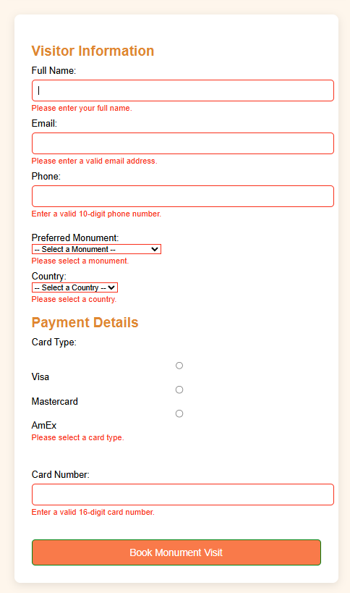

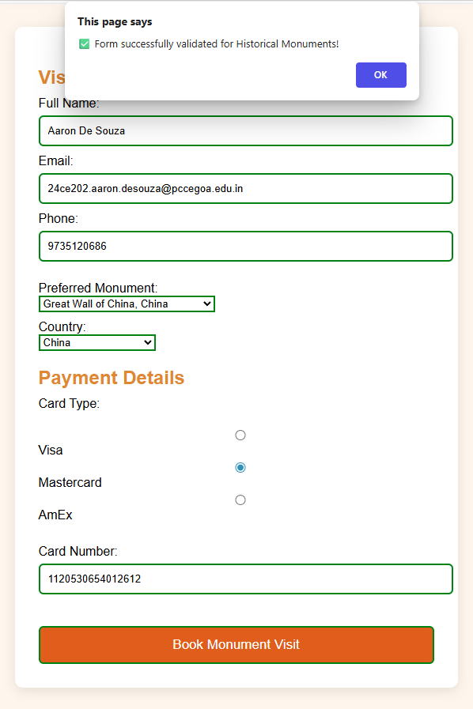

AJAX: xampp

index.html:

<!DOCTYPE html>
<head>
<meta charset="UTF-8" />
<meta name="viewport" content="width=device-width, initial-scale=1.0" />
<title>Historical Explorer - Home</title>
<link rel="stylesheet" href="home.css" />
<script>
// 🕒 Dynamic greeting
window.onload = function () {
const greeting = document.getElementById("greeting");
const hour = new Date().getHours();
let message = "";
if (hour < 12) message = "🌞 Good Morning, Explorer!";
else if (hour < 18) message = "☀️ Good Afternoon, Adventurer!";
else message = "🌙 Good Evening, Historian!";
greeting.textContent = message;
};
</script>
</head>
<body>

<!-- Navbar -->
<nav class="navbar">
<div class="logo">Historical Explorer</div>
<div class="nav-links">
<a href="index.html">Home</a>
<a href="monuments.html">Monuments</a>
<a href="ajax_demo.html">AJAX Demo</a>
<a href="forms.html">Add Monument</a>
</div>
</nav>

<!-- Hero Section -->
<header class="hero">
<div class="hero-text hover-box">
<h1 id="greeting">Loading...</h1>
<p>Travel through history and explore the world's most iconic monuments.</p>
<a href="monuments.html" class="explore-btn">Start Exploring</a>
</div>
</header>

<!-- Intro Section -->
<section class="intro">
<h2>Embark on a Journey Through Time</h2>
<p>
Discover monuments that have stood the test of time — from the grandeur of the
Colosseum to the mystery of the Pyramids. Step into the pages of history today.
</p>
</section>

<!-- Footer -->
<footer>
&copy; 2025 Historical Explorer | Designed by Aaron De Souza
</footer>
</body>
</html>

home.css:

/* General Page Styling */
body {
margin: 0;
font-family: 'Poppins', sans-serif;
background-color: #fff8f0;
color: #333;
}

/* Navbar */
.navbar {
display: flex;
justify-content: space-between;
align-items: center;
background-color: coral;
padding: 14px 25px;
box-shadow: 0 4px 10px rgba(0,0,0,0.1);
}
.logo {
font-size: 22px;
font-weight: bold;
color: white;
}
.nav-links a {
text-decoration: none;
color: white;
margin: 0 10px;
font-weight: bold;
transition: color 0.3s ease; }
.nav-links a:hover {
color: #ffe0b2;
}

/* Hero Section */
.hero {
background: url("images/homebg.jpg") center center / cover no-repeat;
height: 65vh;
display: flex;
justify-content: center;
align-items: center;
text-align: center;
position: relative;
}
.hero::after {
content: "";
position: absolute;
inset: 0;
background: rgba(0, 0, 0, 0.4);
}
.hero-text {
position: relative;
z-index: 1;
color: white;
max-width: 700px;
padding: 40px;
border-radius: 12px;
background: rgba(0, 0, 0, 0.5);
transition: transform 0.3s ease, background-color 0.3s ease;
}
.hover-box:hover {
transform: scale(1.05);
background-color: rgba(0, 0, 0, 0.6);
cursor: pointer;
}
.hero-text h1 {
font-size: 42px;
margin-bottom: 10px;
color: gold;
text-transform: uppercase;
letter-spacing: 2px;
}
.hero-text p {
font-size: 18px;
line-height: 1.6;
}
.explore-btn {
display: inline-block;
margin-top: 20px;
text-decoration: none;
background-color: coral;
color: white;
padding: 12px 28px;
border-radius: 8px;
font-weight: bold;
transition: 0.3s;
}
.explore-btn:hover {
background-color: darkorange;
transform: scale(1.05);
}

/* Intro Section */
.intro {
max-width: 800px;
margin: 50px auto;
background-color: #ffe5b4;
padding: 30px;
border-radius: 12px;
text-align: center;
box-shadow: 0 5px 15px rgba(0,0,0,0.1);
}
.intro h2 {
color: indianred;
margin-bottom: 10px;
}

/* Footer */
footer {
background-color: coral;
color: white;
text-align: center;
padding: 15px;
margin-top: 40px;
}

output:

monuments.html:

<!DOCTYPE html>
<head>
<title>Monuments - Historical Places</title>
<link rel="stylesheet" href="monuments.css">
</head>
<body>
<div class="navbar">

<!-- Navbar -->
<nav class="navbar">
<div class="logo">Historical Explorer</div>
<div class="nav-links">
<a href="index.html">Home</a>
<a href="monuments.html">Monuments</a>
<a href="ajax_demo.html">AJAX Demo</a>
<a href="forms.html">Add Monument</a>
</div>
</nav>
</div>

<header>
<h1>Famous Monuments of the World</h1>
<p>Discover the most iconic landmarks that celebrate the heritage of humanity.</p>
</header>

<main class="places-container">
<div class="place-card">
<img src="https://a.cdn-hotels.com/gdcs/production110/d737/79d01da7-3020-4b44-9f2d-045801e4ba55.jpg" alt="Colosseum, Rome">
<h2>Colosseum</h2>
<p>Located in Rome, Italy — a grand amphitheater that hosted ancient gladiator battles and remains a symbol of Roman engineering.</p>
</div>
<div class="place-card">
<img src="https://www.wanderlustmagazine.com/wp-content/uploads/2023/11/great-wall-of-china.jpg" alt="Great Wall of China">
<h2>Great Wall of China</h2>
<p>A breathtaking fortification stretching over 13,000 miles across northern China.</p>
</div>
<div class="place-card">
<img src="https://upload.wikimedia.org/wikipedia/commons/e/e3/Kheops-Pyramid.jpg" alt="Pyramids of Giza">
<h2>Pyramids of Giza</h2>
<p>One of the Seven Wonders of the Ancient World, near Cairo, Egypt.</p>
</div>
<div class="place-card">
<img src="https://th.bing.com/th/id/R.8f6a6f593b644e713ac92d88d6e8b5cd?rik=r8rwW%2bt5Fm2kRg&riu=http%3a%2f%2ftraveldigg.com%2fwp-content%2fuploads%2f2016%2f06%2fEiffel-Tower-Photo.jpg&ehk=mse3DSca6HAp3G%2bw1d9uANlszXMP7BZ3I4bjmJH49xE%3d&risl=&pid=ImgRaw&r=0" alt="Eiffel Tower">
<h2>Eiffel Tower</h2>
<p>An iconic iron lattice tower located in Paris, France.</p>
</div>
<!-- add more cards or dynamically load them later -->
</main>

<footer>&copy; 2025 Historical Explorer | Designed by Aaron De Souza
</footer>
</body>
</html>

monuments.css:

body {
margin: 0;
font-family: 'Poppins', sans-serif;
background-color: #fff8f0;
color: #333;
text-align: center;
}
.navbar {
display: flex;
justify-content: center;
gap: 12px;
background: linear-gradient(90deg,#ff7f50,#ff9966);
padding: 12px;
}
.navbar a {
color: white; text-decoration: none;
padding: 8px 14px; border-radius: 6px;
font-weight: 600;
}
header { padding: 36px 12px; background: #fff3e0; border-bottom: 4px solid coral; }
header h1 { margin: 0; color: indianred; text-transform: uppercase; }
.places-container {
display: flex; flex-wrap: wrap; justify-content: center;
gap: 22px; padding: 24px; max-width: 1200px; margin: auto;
}
.place-card {
background: white; width: 300px; border-radius: 12px; overflow: hidden;
box-shadow: 0 6px 16px rgba(0,0,0,0.08); transition: transform .2s;
}
.place-card:hover { transform: translateY(-6px); }
.place-card img { width: 100%; height: 200px; object-fit: cover; }
.place-card h2 { color: #d35400; margin: 12px 0 6px; }
.place-card p { padding: 0 12px 18px; color: #555; line-height: 1.4; }
footer { background: coral; color: white; padding: 14px; margin-top: 30px; }

output:

ajax_demo.html:

<!DOCTYPE html>
<html lang="en"><head>
<meta charset="utf-8"><title>AJAX JSON/XML Demo - Historical</title>
<style>
/* (same styling as earlier, kept concise) */
body{font-family:Arial;padding:30px;background:#f3f6fa}
.box{max-width:520px;margin:0 auto;background:#fff;padding:20px;border-radius:10px;box-shadow:0 4px 12px rgba(0,0,0,0.08)}
h2{text-align:center;color:#004aad}
.buttons button{width:100%;margin:6px 0;padding:10px;border-radius:6px;border:none;background:#007bff;color:#fff;cursor:pointer}
#output{margin-top:12px;padding:12px;border-radius:6px;background:#eef5ff;display:none;white-space:pre-line}
label{display:block;margin-top:8px;font-weight:bold}
input[type="text"]{width:100%;padding:8px;margin-top:6px;border-radius:6px;border:1px solid #ccc}
</style>
<script>
function showOutput(text){const o=document.getElementById('output');o.style.display='block';o.textContent=text;}
function getJSON(){fetch('data.json').then(r=>{if(!r.ok) throw new Error('data.json not found'); return r.json()}).then(data=>{
if(Array.isArray(data)){let s='GET JSON (list):\n'; data.forEach((p,i)=> s+=(i+1)+'. '+p.name+' — '+p.country+'\n'); showOutput(s);} else showOutput('GET JSON: '+JSON.stringify(data,null,2));
}).catch(e=>showOutput('Error: '+e.message));}
function getXML(){fetch('data.xml').then(r=>r.text()).then(t=>{
const parser=new DOMParser(); const xml=parser.parseFromString(t,'application/xml');
const places=xml.getElementsByTagName('place'); let s='GET XML:\n';
for(let i=0;i<places.length;i++){ const name=places[i].getElementsByTagName('name')[0].textContent; const country=places[i].getElementsByTagName('country')[0].textContent; s+=(i+1)+'. '+name+' — '+country+'\n'; }
showOutput(s);
}).catch(e=>showOutput('Error: '+e.message));}
function postJSON(){const n=document.getElementById('pname').value||'Unknown'; const c=document.getElementById('pcountry').value||'Unknown';
fetch('server.php',{method:'POST',headers:{'Content-Type':'application/json; charset=UTF-8'},body:JSON.stringify({name:n,country:c})})
.then(r=>r.text()).then(txt=>showOutput('POST JSON → '+txt)).catch(e=>showOutput('Error: '+e.message));}
function postXML(){const n=document.getElementById('pname').value||'Unknown'; const c=document.getElementById('pcountry').value||'Unknown'; const xml=`<place><name>${n}</name><country>${c}</country></place>`;
fetch('server.php',{method:'POST',headers:{'Content-Type':'application/xml; charset=UTF-8'},body:xml}).then(r=>r.text()).then(txt=>showOutput('POST XML → '+txt)).catch(e=>showOutput('Error: '+e.message));}
</script>
</head><body>
<div class="box">
<h2>AJAX JSON / XML Demo (Historical)</h2>
<label>Monument name</label><input id="pname" type="text" placeholder="e.g. Taj Mahal">
<label>Country</label><input id="pcountry" type="text" placeholder="e.g. India">
<div class="buttons">
<button onclick="getJSON()">GET data.json (list)</button>
<button onclick="getXML()">GET data.xml</button>
<button onclick="postJSON()">POST JSON → server.php</button>
<button onclick="postXML()">POST XML → server.php</button>
</div>
<div id="output"></div>
</div>
</body></html>

data.json:

[
{"name":"Colosseum","country":"Italy","description":"Ancient amphitheatre in Rome.","image":"images/colosseum.jpg"},
{"name":"Great Wall of China","country":"China","description":"Historic fortification across northern China.","image":"images/greatwall.jpg"},
{"name":"Pyramids of Giza","country":"Egypt","description":"Ancient pyramids near Cairo.","image":"images/pyramids.jpg"},
{"name":"Eiffel Tower","country":"France","description":"Iron lattice tower in Paris.","image":"images/eiffel.jpg"},
{"name":"Taj Mahal","country":"India","description":"White marble mausoleum in Agra.","image":"images/tajmahal.jpg"},
{"name":"Machu Picchu","country":"Peru","description":"Incan citadel in the Andes.","image":"images/machupicchu.jpg"}
]

data.xml:

<?xml version="1.0" encoding="UTF-8"?>
<places>
<place><name>Taj Mahal</name><country>India</country></place>
<place><name>Colosseum</name><country>Italy</country></place>
<place><name>Great Wall of China</name><country>China</country></place>
</places>

output:

forms.html:

<!DOCTYPE html>
<head>
<meta charset="UTF-8" />
<meta name="viewport" content="width=device-width, initial-scale=1.0" />
<title>Add Monument - Historical Explorer</title>
<link rel="stylesheet" href="home.css" />
</head>
<body>

<nav class="navbar">
<div class="logo">Historical Explorer</div>
<div class="nav-links">
<a href="index.html">Home</a>
<a href="monuments.html">Monuments</a>
<a href="ajax_demo.html">AJAX Demo</a>
<a href="form.html">Add Monument</a>
</div>
</nav>

<section class="intro">
<h2>Add a New Monument</h2>
<form action="validate.php" method="post" enctype="multipart/form-data" novalidate>
<label>Monument Name:</label>
<input type="text" name="name" required><br><br>

<label>Country:</label>
<input type="text" name="country" required><br><br>

<label>Description:</label><br>
<textarea name="description" rows="4" cols="40" required></textarea><br><br>

<label>Upload Image:</label>
<input type="file" name="image" accept="image/*"><br><br>

<input type="submit" value="Submit Monument" class="explore-btn">
</form>
</section>

<footer>
&copy; 2025 Historical Explorer | Designed by Aaron De Souza
</footer>

</body>
</html>

validate.php:

<?php
// validate.php - handles form validation and saves to file

if ($_SERVER["REQUEST_METHOD"] == "POST") {
$name = trim($_POST["name"] ?? '');
$country = trim($_POST["country"] ?? '');
$description = trim($_POST["description"] ?? '');

$errors = [];

if ($name == '') $errors[] = "Name is required.";
if ($country == '') $errors[] = "Country is required.";
if ($description == '') $errors[] = "Description is required.";

// Handle image upload
$imageName = "";
if (isset($_FILES["image"]) && $_FILES["image"]["error"] == UPLOAD_ERR_OK) {
$uploadDir = "images/";
$imageName = basename($_FILES["image"]["name"]);
move_uploaded_file($_FILES["image"]["tmp_name"], $uploadDir . $imageName);
}

if (!empty($errors)) {
echo "<h3>Form Validation Errors:</h3><ul>";
foreach ($errors as $e) echo "<li>$e</li>";
echo "</ul><a href='form.html'>Go back</a>";
} else {
// Save data into monuments.txt file
$record = "$name | $country | $description | $imageName\n";
file_put_contents("monuments.txt", $record, FILE_APPEND);

echo "<h2>Monument Added Successfully!</h2>";
echo "<a href='file_handling.php'>View Saved Monuments</a>";
}
}
?>

file_handling.php:

<?php
// file_handling.php - displays monuments stored in text file
$file = "monuments.txt";

echo "<h2>Saved Monuments List</h2>";
if (file_exists($file)) {
$lines = file($file, FILE_IGNORE_NEW_LINES);
echo "<table border='1' cellpadding='8'><tr><th>Name</th><th>Country</th><th>Description</th><th>Image</th></tr>";
foreach ($lines as $line) {
list($name, $country, $desc, $image) = explode(" | ", $line);
echo "<tr>";
echo "<td>$name</td>";
echo "<td>$country</td>";
echo "<td>$desc</td>";
echo "<td>";
if (trim($image) != "") {
echo "<img src='images/$image' width='100'>";
} else {
echo "No image";
}
echo "</td></tr>";
}
echo "</table>";
} else {
echo "<p>No monuments saved yet.</p>";
}
?>

server.php:

<?php
header("Content-Type: text/plain; charset=utf-8");
$raw = file_get_contents("php://input");
$contentType = $_SERVER['CONTENT_TYPE'] ?? '';
$contentType = strtolower(explode(';',$contentType)[0]);

if ($contentType === 'application/json') {
$data = json_decode($raw, true);
if ($data === null) { echo "Invalid JSON received."; exit; }
if (is_array($data) && array_keys($data) === range(0, count($data)-1)) {
echo "Received JSON list:\n";
foreach ($data as $i => $item) {
$n = $item['name'] ?? 'Unknown';
$c = $item['country'] ?? 'Unknown';
echo ($i+1) . ". $n — $c\n";
}
} else {
$n = $data['name'] ?? 'Unknown';
$c = $data['country'] ?? 'Unknown';
echo "Received JSON object: $n — $c";
}
}
elseif ($contentType === 'application/xml' || $contentType === 'text/xml') {
libxml_use_internal_errors(true);
$xml = simplexml_load_string($raw);
if ($xml === false) { echo "Invalid XML received."; exit; }
if (isset($xml->place)) {
echo "Received XML list:\n";
foreach ($xml->place as $i => $place) {
$name = (string)($place->name ?? 'Unknown');
$country = (string)($place->country ?? 'Unknown');
echo ($i+1) . ". $name — $country\n";
}
} else {
$name = (string)($xml->name ?? 'Unknown');
$country = (string)($xml->country ?? 'Unknown');
echo "Received XML: $name — $country";
}
}
else {
echo "Unsupported Content-Type. Send application/json or application/xml.";
}
?>

output:

monuments.txt:

